Lab 7 – Aircraft Incidents *(1995 – 2016)*

CS 4460 Intro Info Visualization, Spring 2021 by Dr. Alex Endert

Georgia Institute of Technology

Student: Ahmad Faris Durrani bin Ahmad Shahrir 903439520 ashahrir3

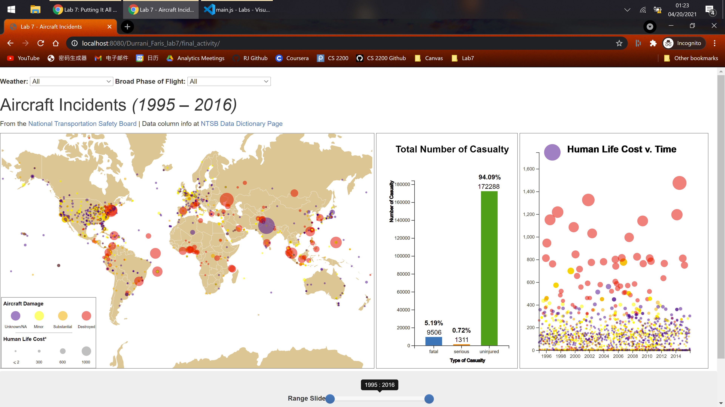

Figure 1: Main Page

# Introduction

This is the final lab programming assignment for this class where the task is to visualize, with a high degree of freedom, a certain dataset chosen from the given datasets for the web, using D3 and JavaScript. Lab 7 is the culmination of this semester’s work and utilizes all the tools we learned so far.

# Dataset Chosen

The dataset I chose for my project is **aircraft_incidents.csv**.

The reason why this one attracted me was the fact there is a list of locations I need to somehow visualize, and I initially planned to make a visualization that centered around a world map plotting all the aircraft incidents in the data. Visualizations centering around world maps have always held a special place in me and I would like to learn to make my own visualization on a world map revolving such an interesting topic I used to watch hours of documentaries on. Though we never learned how to curate a world map in D3, I went up achieve this goal. a not-so-quick Googling helped to show this step is not extremely difficult to accomplish. The main link that helped is provided [here](https://bl.ocks.org/d3noob/5c6eab54c8ca51929734b6f5cca2b231) (d3noob, 2021) though all citations are recorded in the code comments in the main JavaScript file where used.

I also wanted to mirror what was created in (F., 2015) who has done an excellent job visualizing infectious diseases occurrences using well-employed multiple coordinated views.

# List of Analytic Tasks it Supports, Design Overview, and Screenshots

The visualization I created, which employs multiple coordinated views, intends to fulfill these analytical aims:

1. What is the general distribution of the location and how recent each aircraft incidents takes place?
   1. This question asks the user to see the overall data of the location on the world map and filtering roughly by when they occurred.
2. Is there a correlation between the cost of human lives[1], damage to aircraft, and the location where the incidents took place?
   1. The cost of human lives is a weighted measurement of the number of souls affected in each incident, with a fatal and serious injury weighing triple and double the weight of an uninjured casualty. This question intends to encourage the user to analyze the damage each aircraft sustained, and the number of souls affected, comparing them both and comparing with where exactly the incident occurred to find out the degree of losses sustained and whether any one location has a higher probability in terms of pure correlation of being a hotspot for incidents.
3. By how much the weather condition and the broad phase of flight affect the severity/frequency of aircraft incidents?
   1. A hypothesis made during the rough overlook of the raw data is that bad weather condition and the plane being on the ground makes it more likely that an incident took place and the incident costs more human lives. This visualization is fine tuned to be able to filter incidents by the reported weather condition and the broad phase of flight.

This visualization aims to achieve these three goals through filtering and output dependability on a few fronts, along with simultaneously showing three different types of visualizations each with their distinct functions.

Figure 1 shows the main page of this visualization i.e., the first object a user sees on their screen upon loading this visualization. As obvious, the three main components of the page are:

## Global Map

A global map showing the general distribution of aircraft incidents of the data, with each circle representing an incident at its approximate location, color coded by aircraft damage sustained and sized by the cost of human lives (more information in the Legend located at the bottom left of the map).

To create this map, the D3 projection function (main.js:19) needed latitude and longitude information of each incident and unfortunately this part of the dataset was very sparse as seen in Figure 2.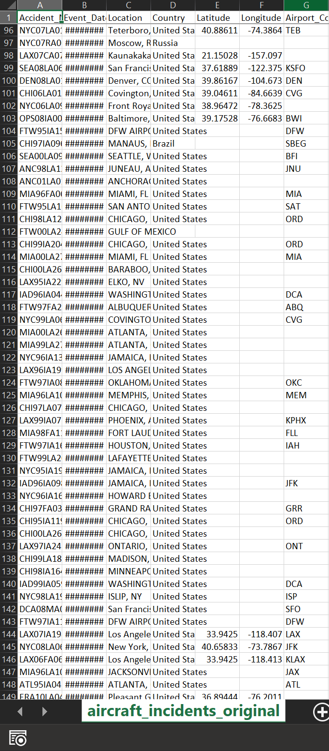

Figure 2: Original aircraft_incidents.csv file with most of the Latitude-Longitude information missing.

But the Location (city) and Country information are given which makes it possible to manually find the Latitude-Longitude information of each incident. At first, I tried finding the Latitude-Longitude of each incident one at a time thorough(Latitude and Longitude Finder, n.d.)butas I reached dozens of rows that need to be changed and later realizing hundreds are missing the Latitude-Longitude, I decided to find an algorithm online to derive the Latitude-Longitude that would take an input of a list of locations and output their Latitude-Longitudes.

The add-on that helped is the Google Sheets extension ‘Geocode by Awesome Table’ (Geocode, n.d.) that automatically populates the Latitude-Longitude into the Google Sheets using one column of locations to make the currently used aircraft_incidents.csv file.

A small disclaimer is that these populated Latitude-Longitude are approximate and may not reflect the exact GPS coordinates of the incident. Where given, the provided Latitude-Longitude coordinates in the original file is used over the populated Latitude-Longitude coordinates.

Using the D3 projection function, the Mercator projection of the world map was initialized, and the locations of each incident given plotted by their Latitude and Longitudes. They are further color coded by the aircraft damage sustained and the cost of human lives.

Another feature this map supports is the ability to hover over the circles (making them higher in opacity) and to show the raw number of fatalities sustained (Figure 3). This interactivity helps to hide irrelevant information from flooding the screen and to allow the user to know exactly the cost of human lives for each circle. As one can easily guess, a user is more likely to hover over big circles and see which aircraft incident are the most serious (and by how much).

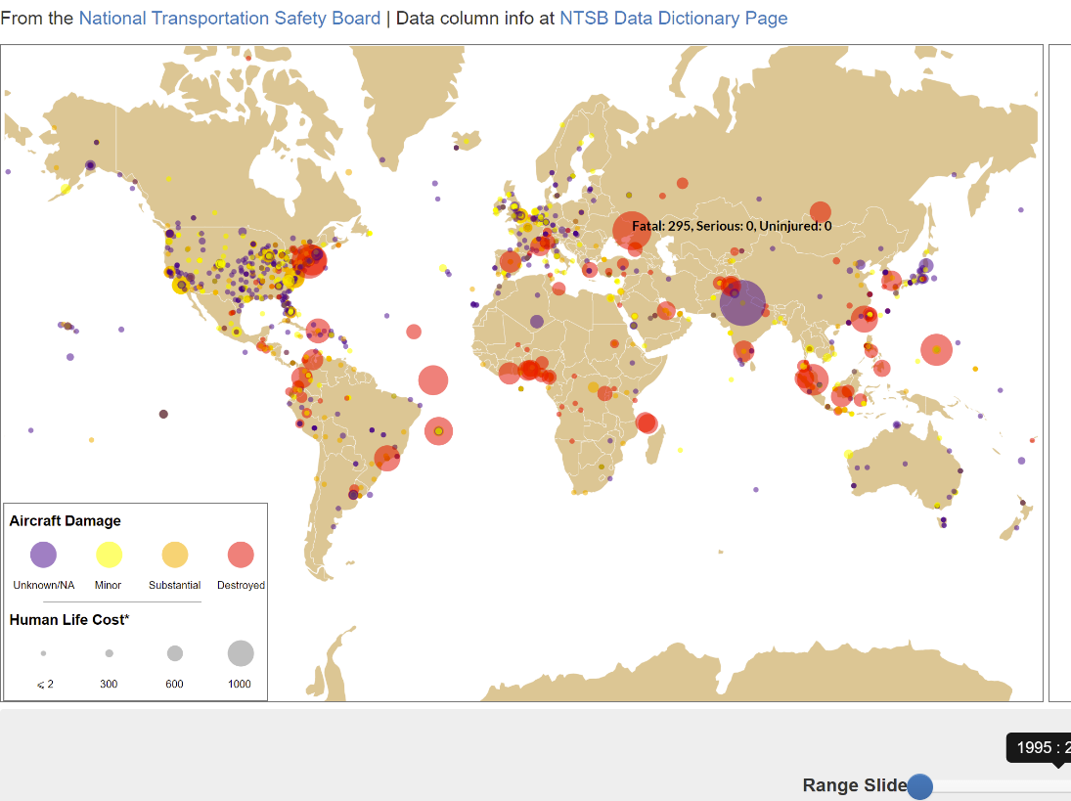

Figure 3: Hovering over the data map reveals fatality information of incidents

## Bar Graph: Total Number of Casualty

To clarify, casualty in this case means the souls involved in the incident whether they are uninjured or not. This simple bar graph shows the raw number (Fatal + Serious + Uninjured) and the percentage of casualty according to their severity case whether that may be Fatal, Serious, or Uninjured. More information about the interactivity this bar graph is given in the coming sections.

For example, in Figure 1, the bar graph shows that there are exactly 9506 fatal casualties in total sustained and 5.19% of all the casualties sustained is Fatal. 0.72% are Serious and 94.09% are Uninjured.

## Scatterplot: Human Lives Cost v. Time

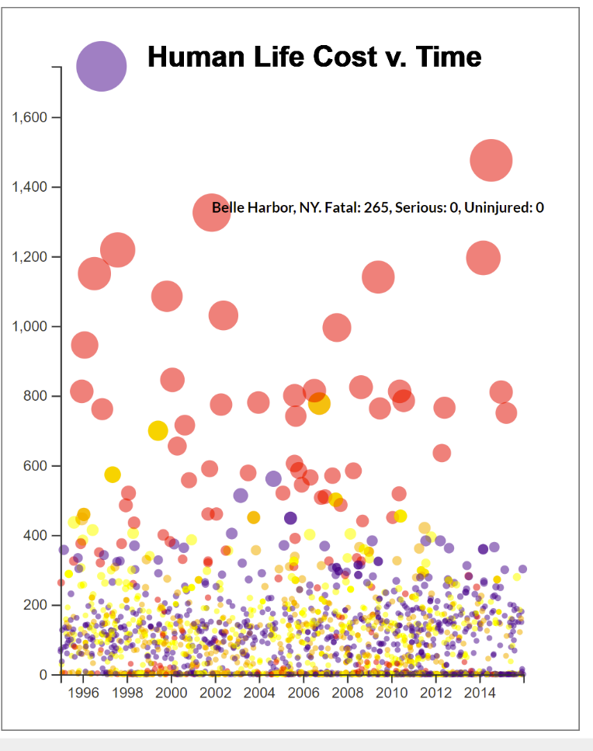This scatterplot plots the incidents that occurred over a scale time and the cost of human lives. Like the world map, this scatterplot of color coded and sized by the damage the aircraft sustained and the cost of human lives, which trivially would mean bigger circles will always be at an elevated position compared to smaller circles.

And this fact helps to emphasize the significance of a serious incident characterized by the number of lives lost or injured. The incidents with more fatalities are placed higher and bigger. Exactly like the world map, a hovering function is provided for the user but this time, the location is also included since there is no other way (aside from guessing by size and color of the circles) which circle points to which location. (Figure 4)

Figure 4: Hovering over scatterplot provides location and fatality information

The scatterplot does not employ axis titles because that information is inferred from the title.

The two additional functions this visualization employs to add to the interactivity are the drop-down functions and the time scale range slider.

## Drop-down Buttons

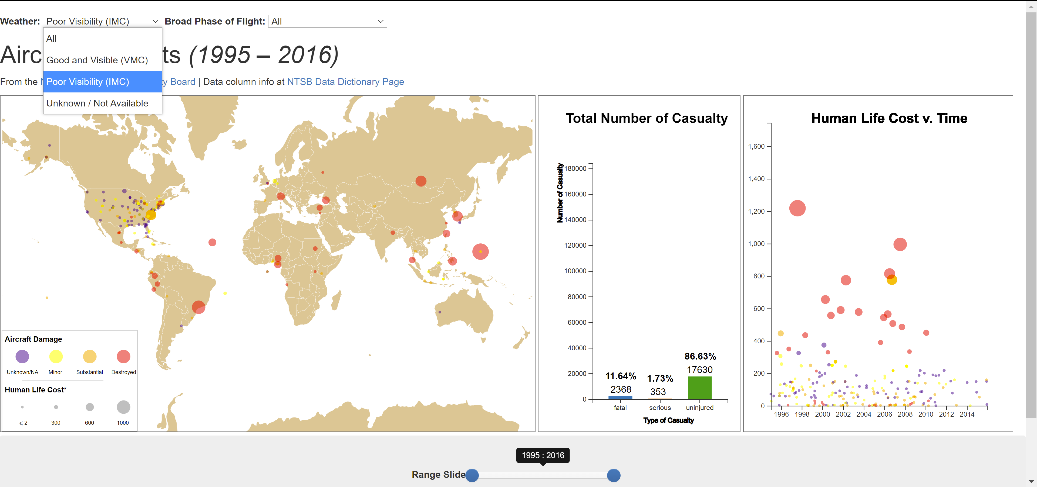

Figure 5: Filtering by Poor Visibility weather conditions using the Weather drop-down button

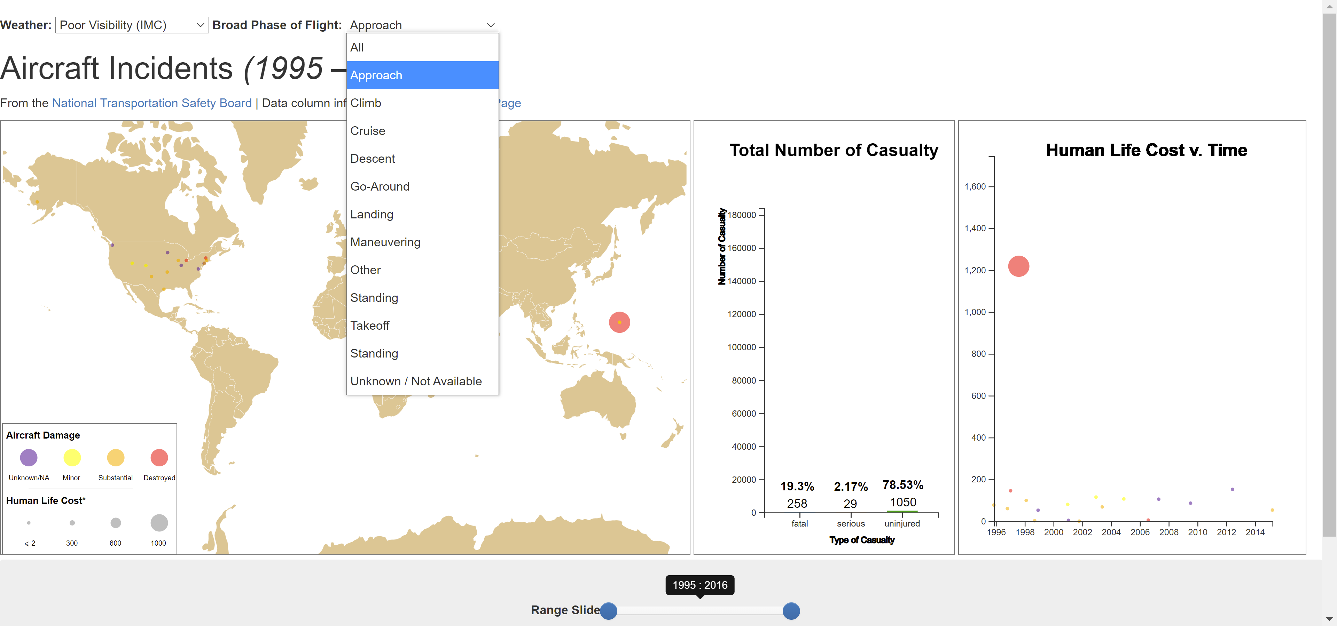

Figure 6: Filtering by Approach broad phase of flight and by Poor Visibility (VMC) weather conditions

The drop-down buttons are trivial in that each dropdown option filters all data by the option selection. For example, choosing the Poor Visibility (IMC) option removes all incident with Good Visibility (VMC) or with Unknown or unavailable information on their weather conditions. These buttons work together to influence the data being displayed on all three main DOM elements i.e., the user can filter by one option in Weather and simultaneously by one option in Broad Phase of Flight.

The user may find it helpful to understand the definition of Poor Visibility (IMC) and Good Visibility (VMC) weather through the links provided in the visualization.

## Time of Incident Range Slider

Lastly, this visualization includes a range slider that filters the data (together with the selected Weather and Broad Phase of Flight options) based on when the incident occurred from a range of the year 1995 to the year 2016. The slider is a two-way slider, so the user may filter based on minimum year and maximum year. (Figure 7)

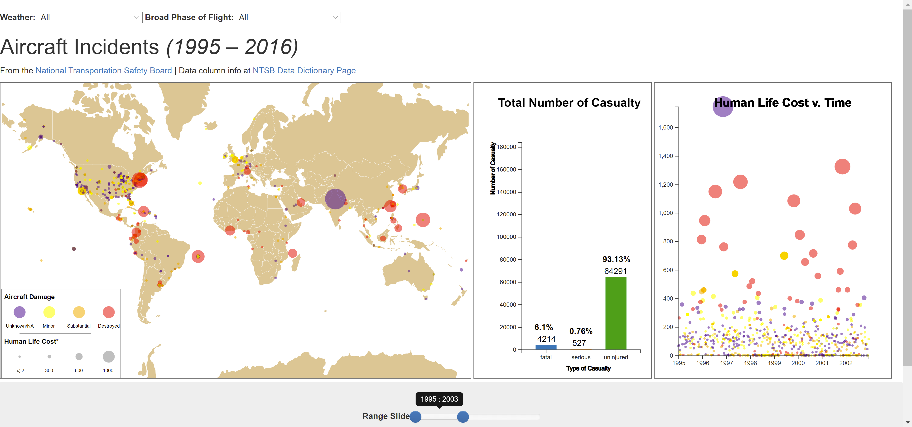

Figure 7: Filtering by year from 1995 to 2003

The user may also realize the axes on the bar graph do not change in scale although the x-axis and only the x-axis of the scatterplot changes in scale to reflect the minimum and maximum year selected by the range slider.

# Overall Analysis Provided

Summing all the tools employed, the user is now able to answer all three questions provided earlier. The world map allows the user to visualize the general distribution of the locations of each aircraft incident and use the time slider to filter out the incidents by the date of occurrence, which helps to provide an idea of when these incidents occurred overall. To aid with that task, the user may also employ the scatterplot to determine the rate of change of each incident over time and hover over the circles to find out their location.

The second question is again aided by both the world map and the bar graph to allow the user to visualize the degree of severity of each incident by their color code and size of circles and plot where they occurred. The user may hover over each circle to get more information and may use the time slider and drop-down options to filter out incidents to focus on a small set of incidents. The bar graph gives information on how the casualty severity changes with each set of incidents.

Lastly, the drop-down options provide users with a way to filter incidents by weather and broad phase of flight, enabling them to visualize whether Weather and Phase of Flight has any effect on incident severity and frequency. The severity and frequency are determined by the number of circles, their colors, radius, and the percentage and raw casualty given by the bar graph.

# Closing Remarks

While this visualization is helpful to provide some insights, as with any other visualization the information painted is limited by the degree of accuracy of the original (and manually extended) data and the limited scope of the tools of this visualization.

# References

d3noob. (2021, March 13). *World Map Centered v5*. Retrieved from bl.ocks.org: https://bl.ocks.org/d3noob/5c6eab54c8ca51929734b6f5cca2b231

F., E. (2015, February 24). *Infectious Diseases: Occurences & Coverage, 1980 - 2015*. Retrieved from Tableau Public: https://public.tableau.com/profile/elias.f.#!/vizhome/InfectiousDiseasesOccurrencesCoverage1980-2015/InfectiousDiseasesIncidenceCoverage-1980-2015?es_p=289187

*Geocode*. (n.d.). Retrieved from Awesome Table Support: https://support.awesome-table.com/hc/en-us/sections/360000012309-Geocode

*Latitude and Longitude Finder*. (n.d.). Retrieved from LatLong.net: https://www.latlong.net/

1. *In this visualization, “cost of human lives” is defined arithmetically as:*

   *Number of fatal casualties × 3 + Number of serious casualties × 2 + Number of uninjured casualties × 1*